


PREPARED BY

Malcolm Reid

ProGlobal Business Advisors

www.ProGlobalBusinessAcademy.com

mreid@proglobalba.com

301.355.2060

For: WR Camps

Attention: Heidi Anderson

Oct 08, 2021

Disclaimer
DISCLAIMER
Certain statements in this Document state our assessment of what your business can achieve given optimum conditions; they do not reflect the average result achieved by other users of our systems over time. The statements are reliant on the information you have provided to us and are reliant on the accuracy and completeness of that information. They may also be affected by a variety of known and unknown risks, variables and other factors which could cause actual values or results, performance or achievements to differ materially from anticipated results, implied values, performance or achievements stated or inferred in the statements. Such risks include the competitive response of your competitors, the state of the economy, changes in government, semi government and municipal regulation, the ability of your organization to implement our systems and undertake such steps as advised by us and the receptiveness of your customer base to your products and services.
Accordingly, in order to make an informed assessment of this offer and whether it is suitable for your needs you need to carefully consider your personal situation, your ability and willingness to implement our systems and the risks that unknown or unexpected factors can have an adverse impact on these assessments and the performance of your business. You should take professional advice on our offer.
All implied terms, conditions, guarantees and warranties (whether statutory or otherwise) (each a “ Term”) are excluded except to the extent that legislation applicable to this Document or the supply of our services imposes a Term which cannot be excluded, restricted or modified. Where such legislation permits the limitation of our liability in respect of breach of that Term, our liability is limited to a refund of the price paid for our services. To the extent permitted by applicable legislation we will not have any liability whatsoever (whether in contract, tort including negligence, pursuant to statute or otherwise) to you for any loss of profits or any indirect or consequential loss or damage of whatsoever kind in respect of our services.
All rights reserved. Neither this Document nor any portion may be reproduced or used in any manner whatsoever without the express written permission of ProGlobal Business Advisors except as mandatorily permitted by applicable legislation.

PURPOSE OF THIS SUMMARY DOCUMENT
The purpose of this proposal is to give an overview of a partnership between WR Camps and ProGlobal Business Advisors to create and implement a strategic sales and marketing plan for Heidi Anderson.
This document will outline the objectives to be reached, the impact to be made, and the time frame in which they are to be accomplished. You have the opportunity to say “YES” to more revenue and profits.


SAY "YES" TO YOUR ROADMAP

The purpose of marketing is basic when you break it down to the core fundamentals. It is the process of:
  - Getting the correct message
  - To the correct audience
  - Via the correct media and methods
  - So, they make the correct decision of buying the solution you offer.

WHEN WE ACCEPT YOU AS A CLIENT, YOUR MARKETING WILL:
1. Be unique (Market Dominating Position) | 9. Create measurable results (test / measure / improve)
2. Be concise (Big words confuse the message) | 10. Target your company strengths
3. Never assume (Eliminate assumptions) | 11. Ask for the order (64% do not ask!)
4. Target an audience (Who wants what you have?) | 12. Capture contact details
5. Provide a solution (Discover a need and fill it) | 13. Provide exceptional value
6. Present compelling offers to ideal prospects | 14. Fuel ‘word-of-mouth’ promotion (Free!)
7. Position you above your competition | 15. Feature successful ‘Buy Now’ strategies
8. Follow a proven ‘roadmap (Failing to plan is a plan to fail) | 16. Drive change ahead of competition (using easy technology)
WHEN WE ACCEPT YOU AS A CLIENT, YOUR MARKETING WILL NOT:
1. Contain boring platitudes (service/quality/dependability)
2. Rely on ‘brand awareness’ (your marketing needs to generate immediate sales)
3. Take customer loyalty for granted
4. Assume something works without ‘testing’ (If you can’t measure it… you can’t manage it)
5. Confuse being ‘busy’… with being ‘successful’
6. Fall into the trap of ‘Analysis Paralysis’

THREE REASONS TO SAY ‘YES’ TO JOIN OUR ‘TEAM’
(Together Everyone Achieves More)

REASON #1
Say ‘YES’ and we will develop with you a strategic business growth roadmap that defines specific monthly goals and marketing objectives. Provided you have an open mind and a willingness to follow our program, we will absolutely make you and your company a more results-based enterprise through this dynamic relationship
The Law of Success dictates that highly successful people have coaches (Tony Robbins, Tom Brady, Lebron James are just a few examples. Those who don’t have coaches… don’t end up on this list.)
Say ‘YES’ to the ‘Law of Success’.
REASON #2
Say ‘YES’ and we will provide access to a roadmap that the proven 'Business Building Superstars' use on a daily basis as organizing principles to accelerate revenues and profits. Applying fundamentals along with cutting-edge results- based techniques will be our mantra.
Success in business is not about mystery; it’s about following a proven roadmap!
REASON #3
Many programs are full of pleasant theories that sound highly impressive but are difficult or impossible to employ in your business. We will implement only proven, breakthrough strategies that can easily be put into place to make a dramatic impact to your marketing and your bottom-line revenue and profits!
Say ‘YES’ to dominating your market!

WR Camps'S CURRENT REALITY
WR Camps already has in place a sales and marketing function that has sales of approximately $900,000 per year. They’re interested in fine-tuning their sales and marketing functions and optimizing their profits.
We agreed that there were 5 areas of impact possible:
Cut Costs
Expected Increase in Revenue | + 4% | + $0
Expected Increase in Profit | + 7% | + $14,040
We’ll ensure that you:
  - You see an instantaneous increase in your overall profits
  - Your staff will play a major role in your cost-cutting initiatives (they already know how to make things more efficient)
  - You’ll renegotiate a majority of your vendor / supplier agreements to much more favorable terms
MARKET DOMINATING POSITION
Expected Increase in Revenue | + 10% | + $90,000
Expected Increase in Profit | + 16% | + $31,500
We’ll ensure that:
  - You separate your business from your competition
  - You target the “hot buttons” of your prospects
  - You become the obvious choice when it comes to buying what you sell
Drip Campaign
Expected Increase in Revenue | + 10% | + $81,063
Expected Increase in Profit | + 14% | + $28,372
We’ll ensure that your sequence of messages:
  - Are compelling and strategic in their content
  - Provide educational value and are not perceived as spam
  - Continuously nurture potential customers who are not ready to buy now
Digital Marketing
Expected Increase in Revenue | + 10% | + $70,983
Expected Increase in Profit | + 13% | + $24,844
When you incorporate a comprehensive Digital Marketing campaign:
  - You’ll get leads from multiple ONLINE sources
  - You’ll be able to direct your prospects based on the products / services they specifically want
  - You’ll be able to test, track, and measure the performance of every lead source
Upsell
Expected Increase in Revenue | + 5% | + $40,496
Expected Increase in Profit | + 7% | + $14,174
We’ll ensure that you:
  - You have systems for upselling and cross-selling multiple items
  - We’ll systemize the entire sales process, so everyone knows what and when to offer to maximize sales
  - Your profits will dramatically increase
Remember that we had agreed to be ultra-conservative with our estimates. It’s possible you could accomplish much more.

THE COST OF CONTINUED INACTION
You’re leaving a significant amount of money on the table every single year based on just these 5 areas of your business:
  - Missed Revenue: $316,800
  - Missed Profit: $124,920
  - Missed Business Value: $114,567
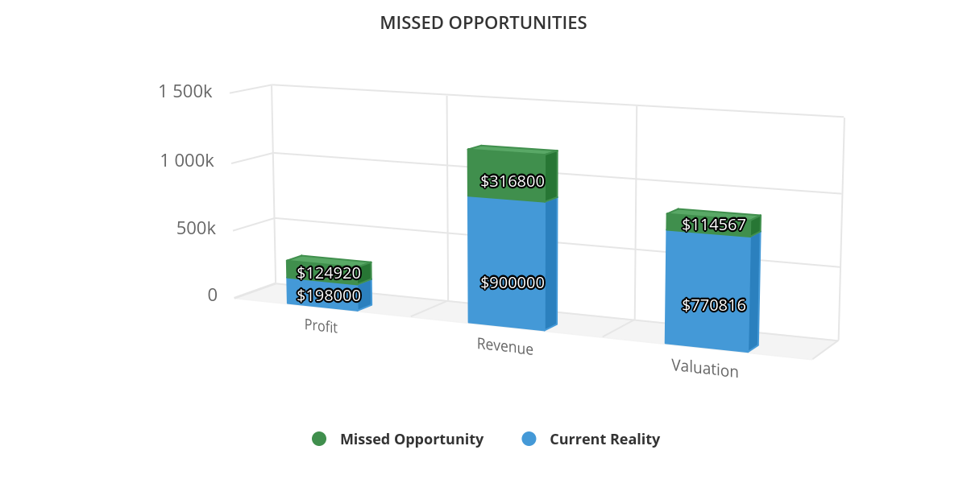

OBJECTIVE OF OUR PROFIT ACCELERATION SUMMARY
We are business building experts, and essentially, we’re coming on board to become your risk- free ‘de facto Business Building Department’.
Our objective is to develop a rock-solid, results-oriented roadmap that results in increased revenue and profits, and a proven system for WR Camps
Say ‘YES’ to following our successful roadmap and it will work forever once implemented.
Good news for you is… you only have to invest once!
THIS IS OUR POTENTIAL IN THE FIRST YEAR!
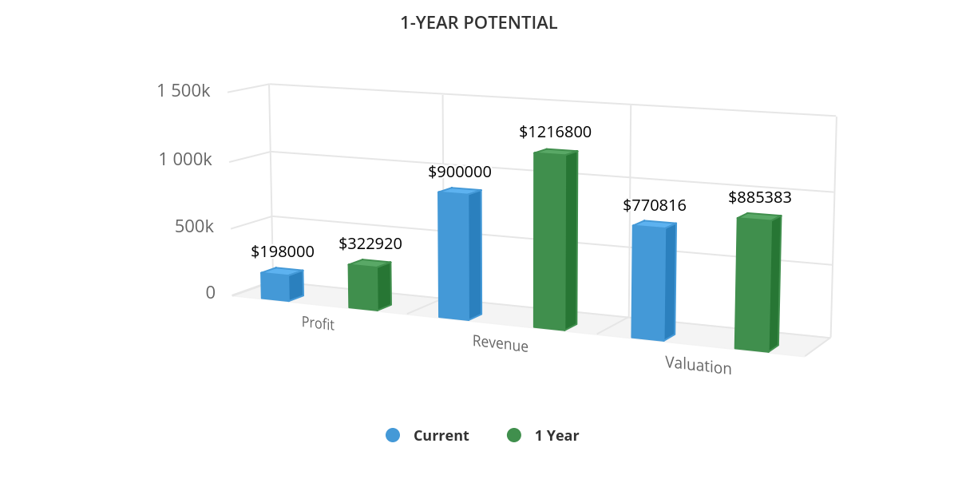

THE FULL PROFIT ASSESSMENT
ProGlobal Business Advisors will first conduct a full Profit Assessment for WR Camps which covers nearly 30 distinct areas of business growth.
The chart below shows the areas where every business can maximize revenue and profits quickly and effectively. We’ll choose the areas that are most applicable to your business and conduct a comprehensive assessment on them.
Our proprietary Profit Acceleration Software will help us detect the financial breakthroughs in each of these areas. It will then prioritize each area and completely remove the guesswork, so we know exactly where to start to make you the most money, in the shortest amount of time, and the least cost.
Most business coaches haven’t caught up with the latest in cutting - edge technology. Unlike most of them who generally follow the “spray and pray” approach, or want to jump right into spending your hard- earned money on the latest social media gimmick, our proprietary software will analyze your business in -depth and identify the lowest hanging fruit in your business so we can instantly begin to increase your revenue and profits.
AREAS OF PROFIT ACCELERATION
Market Dominating Position
Strategy
Trust, Expertise, Education
Policies & Procedures
More Leads
Alliances & Joint Ventures
Referral Systems
Digital Marketing
Drip Campaign
Publicity & PR
Direct Mail
Advertising
Compelling Offer
Sales Team
Scripts
Initial Close Rate
Follow-Up Close Rate
Down-Sell
Additional Products & Services
Reactivate Former Customers
Increase Frequency of Purchase
Increase Price
Upsell & Cross-Sell
Bundling
Increase Longevity of the Buying Relationship
Cut Costs
Systemize Process for Duplication
Other High-Impact Areas
(Time Management, Goal Setting, Productivity, SWOT Analysis, etc.)

THE PRODUCTS & SERVICES INCLUDE:
1. Senior Business Consultant / Marketing Strategist for twelve (12) months to ensure WR Camps’ breakthroughs
2. Half-day confidential business assessment
3. Weekly profitability calls for twelve (12) weeks to ensure WR Camps’ breakthroughs
4. Four (4) quarterly reviews to ensure fulfillment of initiatives for WR Camps.
5. Four (4) quarterly Marketing Roadmaps to ensure fulfillment of initiatives for WR Camps.
6. FULL VIP Access to the ProGlobal Business Academy.
7. Unlimited access via phone or email to ensure implementation of program.
8. 24/7/365 proprietary access to our online resources.
9. Unlimited email / phone support.
10. A 100% results guarantee! (Guarantee is pursuant to client/consultant contract.)

ACCOUNTABILITY
Our objective is to be a long-term player with Heidi Anderson and WR Camps; therefore, we desire to carefully track all results generated by the sales process to measure their effectiveness.
As the project progresses, we will assist in tracking all marketing initiatives, and the results from those expenditures in terms of leads, sales, revenue and profits.
Goals, KPI’s, and results will be discussed regularly to ensure monthly projections and results are being met.


WR Camps INVESTMENT
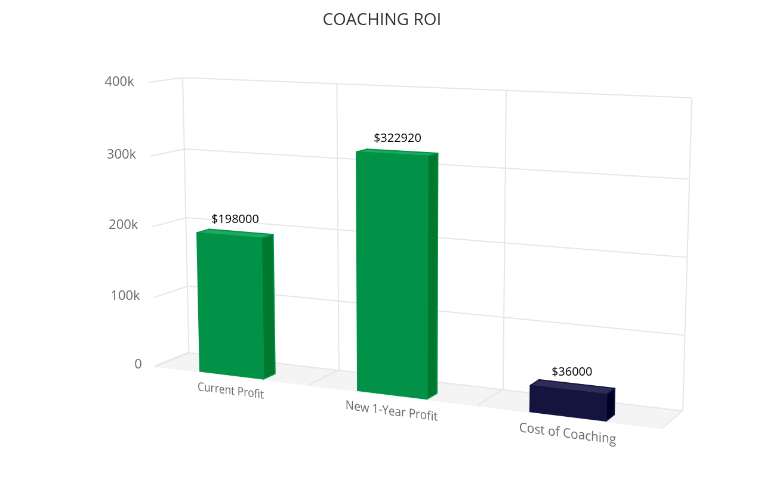
The incredibly low cost of implementing our proven Profit Acceleration System for WR Camps is a $3,000 per month fee, for a twelve (12) month period.
After twelve months, this agreement remains in effect on a month-to-month basis.
Payment is due upon commencement of this Agreement and can be completed by PayPal or Credit Card.
Given your current results of approximately $900,000 in revenue per annum, say ‘YES’ and we will easily provide a solid return on time spent and profitability increases for your investment.

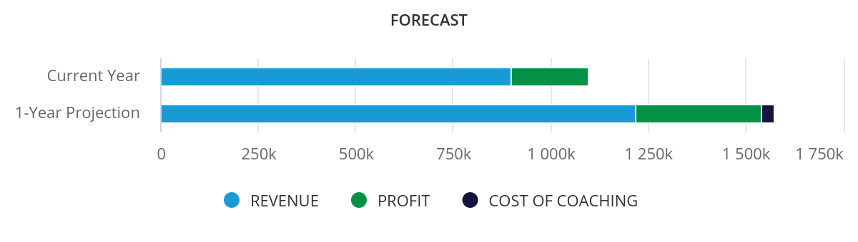

WR Camps AGREEMENT
Please review the separate agreement sent via email

Say ‘YES’ and we will have a rewarding and successful relationship together.

APPENDIX: NOTES
Financials
What is the company's current annual revenue? 900000
What is the company's current net profit margin (NPM) as a %? 22
What is the company's current gross profit margin (GPM) as a %? 35
What industry are you in? Auto & Truck
Valuation
Over the past three years, has your revenue been steady, or growing, or declining? Add or subtract the percentage of growth or decline for 100% (enter 100% if steady). 105
Is your industry in a steady state, or is it in general growth or general decline? Add or subtract the percentage of growth or decline for 100% (enter 100% if steady). 110
If you were to sell all your inventory and assets, what do you think you would get for them? (Give a ballpark figure.) 500000
Do you have financials prepared by an accountant with historical, current and predicted revenue and expenses? No
Do you have one customer that accounts for at least 15% of the overall revenue? No
Is a large extent of all your systems, processes, policies and procedures in place? No
Are your marketing and sales processes documented so that sales are predictable? No
Is your business model scalable? Yes
Is a large percentage of your business recurring revenues? No
What has your business been valued at? If you are not sure, you can use the number already in the box. 630000
Introduction
Why did you start your business? She was running it so why not own it and free her husband up to get him away from his FT Job. Wants a lifestyle friendly business
When did you start it? 1 1/2 yr.
What role do you play in it? GM
Where do you see your business in the next 5 years? (Staff? Revenue?) Loans PIF $425,0000. Main plant manager takes over as GM and her and husband take a Semi-Passive/Passive Role for all.
What are the three biggest problems you currently face in your business? 1. Her systems are not in place - always on hamster wheel - keeps her under control 2. Her ex coworker (competition) - if she is in order, she won't worry about them 3. Retire her husband - Working FT job and 2nd job at shop
(NOTE: Pete - House PIF would allow him to stop - Balance $170k)
Market Dominating Position
What benefit(s) do you offer to your target market that separates you from all of your competitors? Material is more expensive and better material Customer Service Safer Longevity Better resale value
(NOTE: Pete - House PIF would allow him to stop - Balance $170k)
Are those benefits based on the “hot buttons” of your prospects – the problem they have and don’t want and the result they want but don’t have? no
(NOTE: Pete - House PIF would allow him to stop - Balance $170k)
If you could create a Market Dominating Position that addresses both the problems of your clients and the results you provide, by what percent would that impact your business? (Enter as a %) 5
(NOTE: Pete - House PIF would allow him to stop - Balance $170k. - 50/50 on her explanation)
If I were to walk through your business and ask your employees what your Market Dominating Position or USP is, to what degree would I get the same answer? same answer
If we could articulate your unique benefit in a single sentence and have you and your staff use it when speaking with prospects, by what percent would that impact your business? (Enter as a %) 5
Cut Costs
`The industry average GPM and NPM are as follows: GPM: ${gpm} and NPM: ${npm}. ` COMPUTED
`If you could improve your GPM to the industry standard, you would improve your Gross Profits by: ${one_7} or by: ${two_7}. This means a 5-year impact of ${three_7} because you should see that impact last over 5 years if you cement in your changes. ` COMPUTED
Which of these will you commit to? Audit vendors and get better quotes!
By what percent could you reduce your COGS? 2
--- SEPARATOR
`If you could improve your NPM to the industry standard, you would improve your Net Profits by: ${one_2} or by ${two_2}. This means a 5-year impact of ${three_2} because you should see that impact last over 5 years if you cement in your changes. ` COMPUTED
Which of these will you commit to? Organization of shop! Can do maintenance and repairs - understaffed so can't take advantage of this revenue stream
By what percent could you reduce your Overhead? 2
`From this area, we should see a total cost reduction (and therefore a Profit Impact) of <b>${one_11} </b>` COMPUTED
Digital Marketing
Tell me about your Digital marketing strategy Social Media - Each new camp put it out on Social Media (Branding Marketing) Doesn’t have time because they are working daily Landing Page Website to work
How many leads do you get from your website? 25 months
How many leads do you get from marketing online in popular places like social networks, groups, and blogs? FB, Instagram - get engagement and a few leads a month (2 or so)
How many sales do they produce? 2 - 3-year total
If we were to put together a comprehensive digital marketing improvement program for your business that included more compelling marketing and offers online targeted at your ideal clients, by what percent do you think we should be able to increase your revenue? (Enter as a %) 10
(NOTE: This would be HUGE!)
Drip Campaign
Do you currently follow up with your prospects as they move along the buyer’s decision-making process? Tries but too busy and not structured. Sometimes too long in between communications.
Does any of your marketing highlight the benefits of ownership, overcome the objections to ownership and address the important vendor selection criteria? to a small extent.
If we could build marketing and sales material for each aspect of the buyer's decision-making process, by what percent do you think that would impact your growth? (Enter as a %) 5
Drip campaigns are designed to dramatically increase your conversion rates. They require a highly compelling “incentive offer” such as discounts, product / service bundles, free services, etc. Do you currently have any compelling incentive offers for your product / service? Has nothing now. We can create a guide to help client understand MDP
If we could create highly compelling incentive offers targeting specific product/services for your business, what would be the financial impact? (Enter as a %) 5
Upsell & Cross-sell
Do you have up-sell or cross-sell strategies and procedures in place? Does it as needed.
What other products or services could you offer when a customer shows the intention to buy your primary product or service? accessories, custom rims, custom tires, small things to add inside. Needs to systematize.
(NOTE: This would be HUGE!)
Do you currently package products or services (or options) that are complementary to each other as a way to increase your average purchase? yes
Are you aware of any other ways we could maximize your upsell or cross-sell processes? She deals with another company where the salesperson discounts. She feels if she doesn’t give lowest price she will lose.
What would be the impact if we initiated several up-sell and cross-sell strategies to maximize the monetary value that each customer spends with you? (Enter as a %) 5

