Update Report Of 29th May,2019

Todays report include the following tasks;

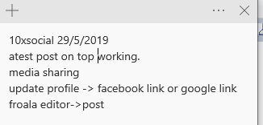

so these were the errors client were asking about

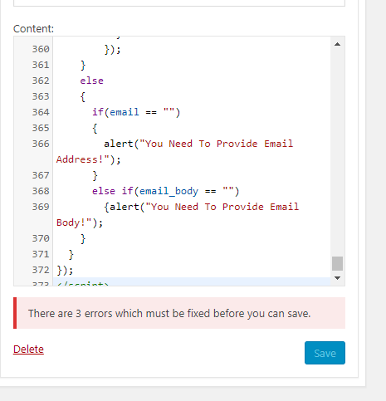

basically these erors was of img tag in search_bot.html file. in 3 img tags there are empty src="" attribute.



so i have configured it with passing the logged in user avatar, sponser image and client logo



the other two errors were also remove however after optimzing the code that model part was removed from code so its working fine now.

for testing purpose created a test wordpress Website for it and then apply the concept through widgets.

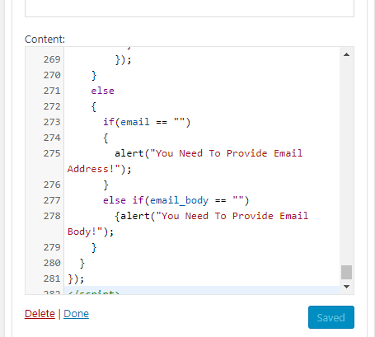

no error in the widget (custom Html).

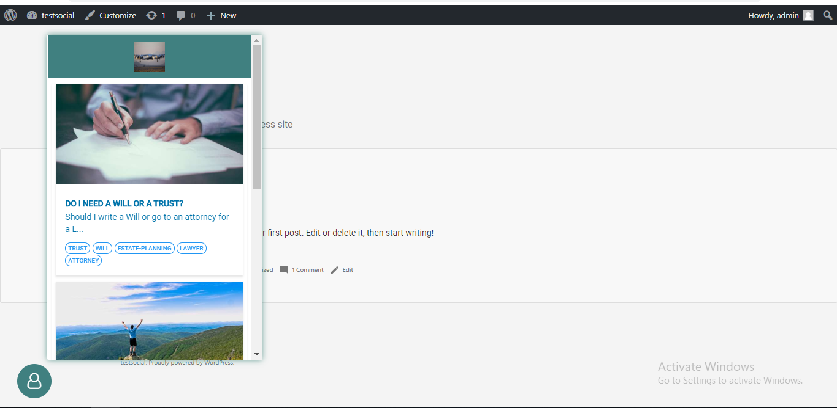

here is the bot . it is showing the latest post on the top. and working fine..

2. media sharing work is removed in the pervious update

3. profile connectivity is underprocesss for both gmail and facebook.

4.i worked on froala updeted it and then reverted it now it will be updated again

Questions

1. we already have connectivity with gmail and facebook. we can log through both of them. so client want connectivity in profile .which sort of connectivity? as there is no

way to connect in other ways.

2.i have searched for sync of google & facebook account, google sync is google account sync. so can we sync google & facebook to our site.

3. what can be the possible solution for froala editor.?